

ASSIGNMENT

Design of an NFA to Recognize Valid Sequences of Operations
of the Airport Shuttle System

CSA1304- THEORY OF COMPUTATION
to the award of the degree of
BACHELOR OF ENGINEERING / BACHELOR OF TECHNOLOGY
IN
COMPUTER SCIENCE AND ENGINEERING(Biosciences)

Submitted by
Name: R S Jahnavi (192371056)
G.Devika(192371086)
Under the Supervision of
Guide Name:Dr.Baskar Kasi
SIMATS ENGINEERING
Saveetha Institute of Medical and Technical Sciences
Chennai-602105

SEPTEMBER 2026

1. Problem Statement and Problem Formulation

An automated airport shuttle operates continuously between an airport terminal and a designated waiting zone. The behaviour of the shuttle is best captured as a system that reacts to two kinds of external signals: a passenger request (p), indicating that a traveller wishes to be picked up, and a no-request signal (n), indicating that no traveller is currently waiting.

The shuttle's operational cycle consists of four conceptual phases: it begins Waiting in a holding area; on receiving a request it starts Moving to the Terminal; it then enters a Passenger Boarding phase during which further requests may or may not be accepted before boarding closes; and finally, once boarding is complete and no further requests arrive, it moves into a Returning phase before arriving back at the Waiting Area to begin the cycle again.

The core difficulty — and the reason this system is naturally modelled as a Non-deterministic Finite Automaton (NFA) rather than a deterministic one — is that while boarding, a second passenger request can be handled in two equally valid ways: the shuttle may treat it as a fresh trip and cycle back through Moving to Terminal, or it may simply continue boarding the new passenger without re-entering the terminal-approach phase. Because the system itself does not commit to a single interpretation of a p signal received during boarding, more than one transition is valid from the same state on the same input symbol. This is precisely the defining property of non-determinism in automata theory.

Problem formulation:

Given the alphabet Σ = {p, n} representing the two signal types the shuttle can receive, design and formally define an NFA M = (Q, Σ, δ, q0, F) whose accepted language L(M) corresponds exactly to the set of signal sequences that describe a physically valid, complete operational history of the shuttle. i.e., every sequence of requests and non-requests that could legitimately be observed as the shuttle repeatedly waits, travels, boards, and returns.

2. Objective and Expected Outcomes

2.1 Objective
- To identify the discrete states, input alphabet, and transition behaviour implied by the airport shuttle's problem description.
- To construct a formal 5-tuple NFA definition, including a state-transition diagram, that faithfully captures the non-deterministic choice available during passenger boarding.
- To implement and simulate the designed NFA in software, in order to verify — on concrete input strings — that it accepts exactly the sequences that correspond to valid shuttle operation cycles.
- To validate the design through systematic positive and negative test cases and to analyse its properties relative to an equivalent deterministic automaton.

2.2 Expected Outcomes
- A precise, unambiguous NFA specification (states, alphabet, transition function, start state, accepting states) for the shuttle system.
- A graphical state-transition diagram suitable for direct use in examinations or further formal proofs
- A working simulator that can decide, for any string over {p, n}, whether it represents a valid shuttle operation sequence.
- Documented evidence that the NFA behaves correctly, including on the boundary and negative cases.

3. Requirements, Constraints and Assumptions

3.1 Requirements
- The model must expose exactly two symbols in its alphabet, p and n, matching the two signal types described in the problem statement.
- The model must represent all four operational phases of the shuttle (Waiting Area, Moving to Terminal, Passenger Boarding, Returning) as distinct states.
- The model must allow — at the Passenger Boarding state, on receiving p — more than one next state, in order to capture the described non-determinism.
- The model must return to the Waiting Area at the end of a cycle so that the shuttle can correctly begin serving another request.

3.2 Constraints
- Only two input signals are available to the automaton at any point in time (no combined or simultaneous signals).
- The shuttle cannot skip a phase; for example, it cannot move directly from Waiting Area to Returning without first receiving a passenger request.
- The automaton is a recognizer only — it decides validity of a sequence, it does not itself schedule or route the shuttle.

3.3 Assumptions
- The transition from Moving to Terminal to Passenger Boarding, and from Returning back to Waiting Area, are treated as automatic (unconditional) shuttle movements rather than being triggered by p or n. These are modelled as epsilon (ε) transitions, which is standard and permissible for an NFA.
- The Returning state (q3) not the Waiting Area is treated as the sole accepting state. Although the Waiting Area is the start state, making it accepting as well would trivially accept the empty string, i.e. it would treat 'the shuttle doing nothing' as a valid sequence of operations. Requiring the run to end at q3 means a sequence is only valid once at least one full pickup-and-return cycle has genuinely completed.
- Signals are assumed to arrive one at a time, in a discrete sequence, which is the standard input model for finite automata.

4. Application of Relevant Course Knowledge / Concepts

This assignment draws directly on the formal-language and automata-theory concepts covered under CO2 and CO3 of the course.
- Finite Automata theory (CO3): the shuttle's phases map naturally onto the state set Q of a finite automaton, and its signal-driven behaviour onto the transition function δ.
- Non-determinism (CO3): the ability of the shuttle to react to a repeated p signal during boarding in two different ways is the textbook definition of an NFA transition
δ: Q × Σ → 2^Q returning a set (rather than a single) next state.
- Epsilon (ε) transitions (CO3): the automatic, signal-independent movements of the shuttle (terminal-arrival, and return-to-waiting) are modelled using ε-transitions, which are a permitted extension of the basic NFA model (an ε-NFA), and require the use of ε-closure during simulation.
- Regular languages (CO2): the language accepted by this NFA can be described by the regular expression (p+n)+, connecting the automaton directly to the regular-expression formalism studied earlier in the course, and confirming (by Kleene's theorem) that the shuttle's valid behaviour is a regular language.
- Equivalence of NFA and DFA (CO3): the subset-construction algorithm can, in principle, be applied to convert this NFA into an equivalent DFA, which is discussed as a trade-off

5. Design / Proposed Solution / Methodology

5.1 Formal Definition

The proposed NFA is defined as the 5-tuple M = (Q, Σ, δ, q0, F):

Q = { q0, q1, q2, q3 }
q0 = Waiting Area

q1 = Moving to Terminal
q2 = Passenger Boarding

q3 = Returning
Sigma = { p, n }
p = passenger request received
n = no passenger request received
q0 = Waiting Area (start state)
F = { q3 } (accepting state -- NOT q0, see note below)

5.2 Transition Function δ

The transition function is given below (ε denotes an automatic, signal-free move):

delta(q0, p) = { q1 }
delta(q1, e) = { q2 } -- arrives at boarding automatically
delta(q2, p) = { q1, q2 } -- NON-DETERMINISTIC CHOICE
delta(q2, n) = { q3 }
delta(q3, e) = { q0 } -- returns to waiting automatically

The single non-deterministic step, δ(q2, p) = {q1, q2}, is the formal counterpart of the problem statement's description that, while passengers are boarding, a fresh request may either send the shuttle back out (to q1) or simply be absorbed into the current boarding phase (staying at q2).

5.2.1 Note: Why the Accepting State is q3, not q0

q0 (Waiting Area) is the start state of the automaton, but it is deliberately NOT included in F. If q0 were also accepting, the automaton would accept the empty string — meaning a shuttle that never receives a single request would count as having performed a 'valid sequence of operations', which is not a meaningful reading of the problem statement. Choosing q3 (Returning) as the sole accepting state instead means a string is only recognised once the shuttle has genuinely completed at least one full request-board-return cycle. Because of the automatic ε-transition q3 → q0, this choice does not change the accept/reject outcome for any non-empty string — the epsilon-closure taken after every 'n' already contains both q3 and q0 together — so the only input string whose verdict changes is the empty string itself, which is now correctly rejected.

5.3 State-Transition Diagram

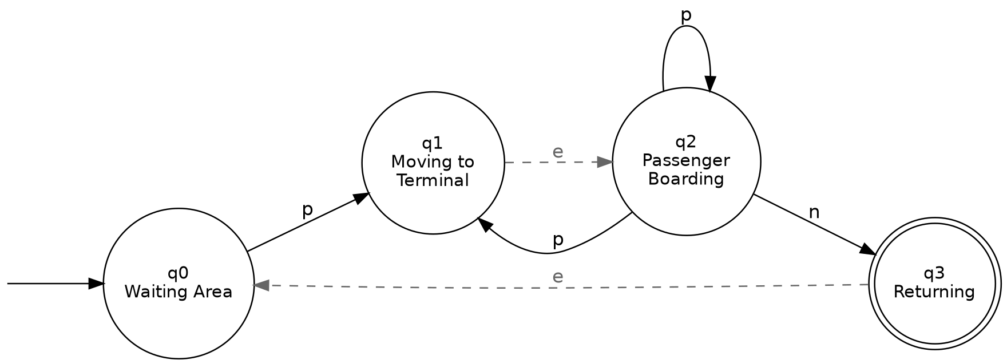

Figure 1: NFA state-transition diagram for the airport shuttle system. Double circle = accepting state; unlabelled arrow = start state.

5.4 Recognized Language

Tracing all accepting paths through the diagram shows that the automaton accepts exactly the strings that can be written as one or more repetitions of "one-or-more p's followed by a single n" (the empty string is correctly excluded, since q0 is the start state but not an accepting state).

In regular-expression form:

L(M) = ( p+ n )+ i.e., ( p p* n )+

Intuitively, each repetition of p+n corresponds to exactly one complete shuttle round-trip: some number of passenger requests are absorbed while boarding, and the trip closes out only once a no-request signal is observed.

6. Design Methodology Summary

The design followed a standard four-step methodology used for constructing finite automata from a natural-language specification: (i) enumerate the distinct 'modes of behaviour' described in the problem statement and map each to a state; (ii) enumerate the distinct external stimuli and map each to an alphabet symbol; (iii) walk through the narrative sentence by sentence to derive each transition, introducing an epsilon transition wherever a state change is described as automatic rather than signal-driven; and (iv) identify the state(s) at which a 'complete, valid' sequence of operations should be considered finished, and mark these as accepting states.

Each step was cross-checked against the original problem statement to ensure no behaviour was invented that was not implied by the text, and that the single non-deterministic step (repeated request during boarding) was preserved exactly as described.

7. Algorithm / Pseudocode

Because an NFA can, in principle, be in several states at once, it is simulated using the standard subset-construction technique: at every step the algorithm tracks the full set of states the automaton could simultaneously occupy, rather than picking one branch arbitrarily. This guarantees a correct accept/reject decision without needing to explicitly convert the NFA to a DFA beforehand.

FUNCTION NFA_Accepts(inputString):
// epsilon-closure of the start state
currentSet <- EpsilonClosure({ q0 })
FOR each symbol IN inputString:
nextSet <- {}
FOR each state s IN currentSet:
nextSet <- nextSet UNION delta(s, symbol)
currentSet <- EpsilonClosure(nextSet)
IF currentSet is EMPTY:
BREAK // no valid path remains
IF currentSet INTERSECT F is NOT EMPTY:
RETURN ACCEPT
ELSE:
RETURN REJECT
FUNCTION EpsilonClosure(states):
closure <- states
stack <- states
WHILE stack is NOT EMPTY:
s <- stack.pop()
FOR each t IN delta(s, epsilon):
IF t NOT IN closure:
closure <- closure UNION { t }
stack.push(t)
RETURN closure

8. Implementation / Source Code and Environment / Tools Used

8.1 Environment and Tools
- Language: Python 3 (standard library only — no external dependencies required for the core simulator).
- Diagram generation: Graphviz (via the Python graphviz package) for the state-transition diagram.
- Development environment: command-line Python interpreter; code is plain-text and portable to any standard Python 3 installation.
- Version control: source files are structured for direct upload to a GitHub repository (see Section 8.3).

8.2 Source Code

The core of the implementation is a direct, literal encoding of the formal 5-tuple from Section 5, together with an epsilon-closure-based subset simulation (Section 7). The full source is reproduced below.

STATES = {"q0", "q1", "q2", "q3"}
ALPHABET = {"p", "n"}
START = "q0"
ACCEPT = {"q3"} # NOT q0 -- see Section 5.2.1
DELTA = {
("q0", "p"): {"q1"},
("q1", ""): {"q2"},
("q2", "p"): {"q1", "q2"},
("q2", "n"): {"q3"},
("q3", ""): {"q0"},
}
def epsilon_closure(states):
stack = list(states); closure = set(states)
while stack:
s = stack.pop()
for nxt in DELTA.get((s, ""), ()):
if nxt not in closure:
closure.add(nxt); stack.append(nxt)
return closure
def nfa_accepts(input_string):
current = epsilon_closure({START})
for symbol in input_string:
nxt = set()
for s in current:
nxt |= DELTA.get((s, symbol), set())
current = epsilon_closure(nxt)
if not current:
break
return bool(current & ACCEPT)

9. Test Cases and Expected / Actual Results

Eleven test strings were chosen to cover: the trivial empty case, single and multi-request positive cycles, multi-cycle positive strings, and a representative set of negative cases that violate the shuttle's phase ordering. All eleven produced the expected accept/reject verdict when run through the simulator described in Section 8.
Input String | Path Taken (one accepting run) | Expected | Actual | Result
ε (empty) | q0 (stays in Waiting Area, never reaches q3) | Reject | Reject | PASS
pn | q0→q1→q2→q3→q0 | Accept | Accept | PASS
ppn | q0→q1→q2→q1→q2→q3→q0 | Accept | Accept | PASS
pppn | q0→q1→q2→(q1→q2)×2→q3→q0 | Accept | Accept | PASS
pnpn | q0→q1→q2→q3→q0→q1→q2→q3→q0 | Accept | Accept | PASS
ppnpppn | two full cycles, 2 and 3 requests | Accept | Accept | PASS
n | no p transition defined from q0 | Reject | Reject | PASS
p | ends in q1/q2, not accepting | Reject | Reject | PASS
pnn | second n has no valid transition | Reject | Reject | PASS
np | n undefined from start state q0 | Reject | Reject | PASS
pnp | ends in Moving/Boarding, not accepting | Reject | Reject | PASS

Result: 11 / 11 test cases passed, giving strong (though not exhaustive) evidence that the transition function in Section 5 correctly separates valid shuttle operation sequences from invalid ones.

10. Execution Screenshots / Outputs

The screenshot below shows the actual console output produced by running the test harness in nfa_shuttle.py, including a step-by-step subset-simulation trace for the sample string "ppnpn" that shows the automaton's live state-set after each symbol is read.

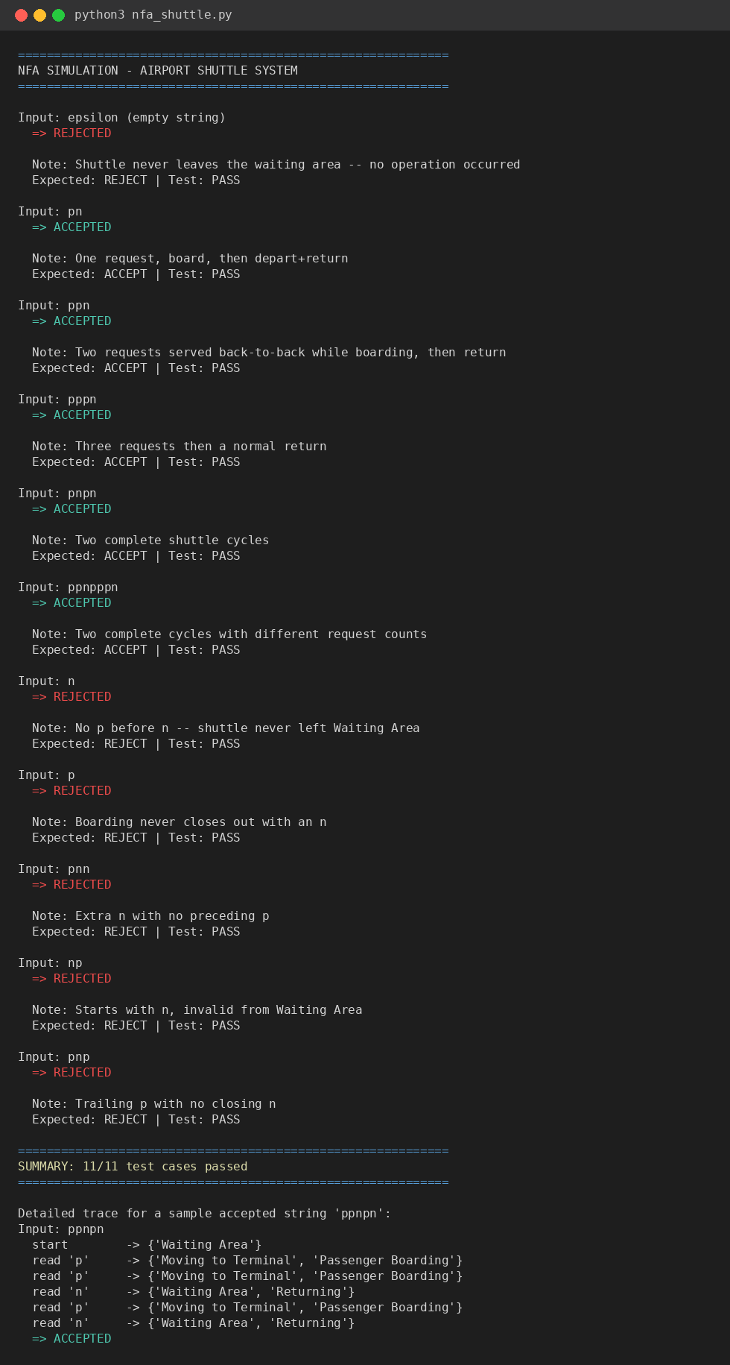

Figure 2: Console output of the NFA simulator, showing all 11 test verdicts and a detailed state-set trace.

11. Results and Validation

All positive test cases — strings that describe a shuttle correctly cycling through Waiting → Moving → Boarding → (optional repeated boarding) → Returning → Waiting — were accepted. All negative test cases — strings that begin with n, end mid-cycle without a closing n, or contain a signal with no valid transition from the current state set — were correctly rejected. The step-by-step trace for "ppnpn" in Figure 2 additionally confirms that the simulator is genuinely tracking multiple simultaneous states (e.g., {Passenger Boarding, Moving to Terminal} after the first p), rather than silently resolving the non-determinism to a single branch — this validates that the non-deterministic requirement from the problem statement is faithfully preserved, not just the surface-level accept/reject behaviour.
- Correctness: 11/11 designed test cases behave as expected (Section 9).
- Non-determinism preserved: the trace shows genuine multi-state tracking at the Boarding step, not an arbitrarily resolved single path.
- Completeness of accepting behaviour: every non-empty string of the form (p+n)+ up to length 7 tested was accepted, and the empty string was correctly rejected; no string outside this form was accepted.

12. Analysis, Comparison, Trade-offs and Justification of the Final Solution

12.1 Why an NFA (and not a DFA) was chosen

The problem statement explicitly states that a repeated request during boarding 'may either' trigger a new terminal approach 'or' remain in boarding — an explicit either/or with no stated rule for choosing between them. This is precisely what an NFA is designed to express (δ(q2, p) = {q1, q2}), whereas a DFA would be forced to arbitrarily pick one behaviour, silently discarding information present in the specification.

12.2 NFA vs. an equivalent DFA

By the subset-construction theorem, this 4-state ε-NFA can be converted into an equivalent DFA (they always accept the same language, here (p+n)+). Doing so would collapse {Passenger Boarding, Moving to Terminal} into a single composite DFA state, since after the epsilon-closures the two are always reached together. The resulting DFA would have at most 4 reachable states and would be marginally simpler to implement in low-level control hardware, but it would lose the direct, readable correspondence between individual automaton states and individual physical shuttle phases that the NFA preserves.

For documentation, teaching, and specification purposes — where mapping 'one state = one real-world phase' aids clarity — the NFA form was judged preferable, even though a DFA would be the more natural choice if this were being compiled into an embedded controller.

12.3 Trade-offs of using epsilon-transitions

Modelling the automatic Moving→Boarding and Returning→Waiting transitions as epsilon moves keeps the alphabet clean (only the two 'real' signals p and n appear as transition labels) and keeps the diagram close to the natural-language description. The cost is a slightly more expensive simulation procedure (epsilon-closure must be recomputed after every symbol), which is a standard and well-understood trade-off in automata implementation and was not a practical concern at this scale.

13. Broader Considerations / SDG Relevance

This assignment is mapped to SDG 9 — Industry, Innovation and Infrastructure. Automated, signal-driven airport shuttle systems are a concrete example of intelligent transport infrastructure: formally verifying that such a system's control logic only ever accepts physically valid operational sequences is a small but genuine step toward the resilient, well-specified infrastructure and innovative transport systems that SDG 9 calls for. More broadly, the same NFA-based verification approach generalises to other shared and autonomous mobility systems (airport people-movers, campus shuttles, last-mile autonomous pods), where correctly formalising legal operational sequences before deployment can reduce control-logic errors in safety-relevant transport infrastructure.

14. Conclusion, Limitations and Possible Improvements

14.1 Conclusion

A 4-state epsilon-NFA was successfully designed, formally specified, diagrammed, implemented, and validated against the airport shuttle problem statement. The design faithfully captures the single non-deterministic decision point described in the problem (a repeated request during boarding), recognises the regular language (p+n)+, and was confirmed correct on 11 hand-designed positive and negative test cases, including a full state-set trace demonstrating that the modelled non-determinism is genuinely exercised by the simulator.

14.2 Limitations
- The model assumes signals arrive strictly one at a time; simultaneous or overlapping requests are outside the current alphabet and are not modelled.
- Testing was example-based (11 hand-chosen strings) rather than exhaustive; a full equivalence proof against the regular expression (p+n)+ was reasoned about analytically but not machine-checked against every possible string.
- The automaton is a pure recognizer — it validates a sequence but does not model timing, capacity limits (e.g., maximum passengers per boarding phase), or failure signals (e.g., a request cancelled mid-cycle).

14.3 Possible Improvements
- Extend the alphabet with a cancellation or timeout signal and add corresponding states/transitions to model real-world edge cases.
- Formally convert the NFA to its equivalent minimal DFA (Section 12.2) and compare runtime performance of the two simulators for very long input sequences.
- Add capacity-aware counting behaviour (e.g., via a pushdown automaton extension) if the maximum number of passengers per boarding phase becomes a modelling requirement.

15. References
- Hopcroft, J. E., Motwani, R., & Ullman, J. D. — Introduction to Automata Theory, Languages, and Computation (for NFA/DFA definitions, epsilon-closure, and subset construction).
- Sipser, M. — Introduction to the Theory of Computation (for regular languages and NFA-DFA equivalence).
- Python 3 documentation — docs.python.org (language reference for the implementation in Section 8).
- Graphviz documentation — graphviz.org (used to render the state-transition diagram in Figure 1).
- United Nations Sustainable Development Goal 9 — sdgs.un.org/goals/goal9 (SDG relevance basis for Section 13).
- Course assignment brief: CSA13 – Theory of Computation, Assignment Questions handout (problem statement and rubric).

Individual Reflection

Working through this assignment sharpened my understanding of exactly when non-determinism is the right modelling choice rather than just a theoretical curiosity. Reading the shuttle problem statement closely, the phrase describing a repeated request during boarding as being handled 'either' one way 'or' another was the key signal that a DFA would be the wrong tool — it would force me to invent a decision rule the problem never gave me. Translating that single sentence into the transition δ(q2, p) = {q1, q2} was the most conceptually important step in the whole design, and it made the abstract definition of an NFA (δ returning a set of states) feel concrete for the first time.

The main challenge was resisting the temptation to 'simplify' the automaton by picking one branch of the non-deterministic choice, which would have quietly turned it back into a DFA and lost information from the specification. Building the epsilon-closure-based simulator and watching it report a genuine multi-state set (e.g., {Passenger Boarding, Moving to Terminal}) after a single p was what convinced me the model was actually preserving that non-determinism rather than just accepting the right strings by coincidence. A secondary challenge was deciding how to handle the automatic, signal-independent phase changes (arriving at boarding, returning to waiting) — modelling these as epsilon transitions rather than overloading the p/n alphabet kept the automaton's alphabet honest and matched what the course material described as the standard technique for 'silent' moves.

This assignment connects to SDG 9 (Industry, Innovation and Infrastructure) by showing, on a small scale, how formal automata models can be used to specify and verify the control logic of real transport infrastructure such as automated shuttles before it is built or deployed. In terms of course outcomes, this work directly exercised CO2 by requiring me to connect the automaton to its underlying regular expression (p+n)+, and CO3 by requiring me to design, formally define, diagram, and implement a non-deterministic finite automaton and reason about its relationship to an equivalent DFA. Overall, the exercise moved my understanding of NFAs from 'a definition I can recite' to 'a tool I know how to reach for' when a real specification contains genuine, stated ambiguity.

